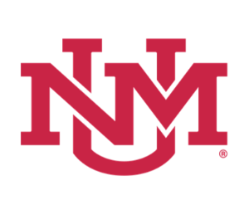
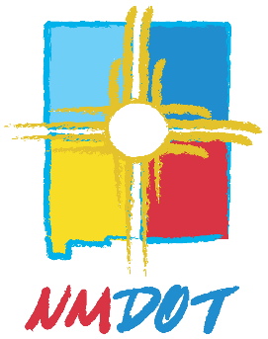
University of New Mexico
Transportation Safety Center

Driver Education Guest Speaker Request

Section 1- Guest Speaker Information
Guest Speaker Name:
Official Title:
Topic:
Time Allotted:
Credentials/Certificates:

Section 2-Driver Education School Information
School Name:
School Physical Address: (Street Address, City, State, Zip Code):
Name of School Owner/Operator (responsible for compliance with state law):

Will this speaker be at any of your extension site locations? Yes No_
*(If so please list extension site locations)*

Section 3 - Please state the guest speaker relevance to your driver education program below.

AdditionalComments
Section 4 – Signature and Date

By my signature below, I certify, under penalty of perjury, that the information given in this application and all accompanying documents is true to the best of my knowledge and ability.

__________________________________________ _________________________
Applicant’s signature Date

Please note that TSD requires an original application for processing. Copies will not be accepted. Please make a copy of this application for your records and submit an original.

TSC Review by _______________________________ Date _________________

NMDOT TSD_________________________________ Date__________________

Approved Denied Date

Please submit this form to: University of New Mexico
Transportation Safety Center
Attn. Program Manager
4400 Alameda Blvd NE
Suite A
Albuquerque, NM 87113

Or by Email: TSCdriverprograms@unm.edu
Attn: Program Manager

If you have any questions, please call UNM Transportation Safety Center at:
505-328-9338

